Kenimer Lewis
Virgil Grissom High School
“Daughter (A Reason to Hope)
Spoken word Post Rock-Instrumental original composition.

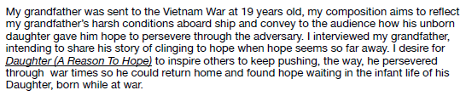
Technical statement to serve in place of a score
"Daughter" is a spoken word study with a post-rock instrumental accompaniment featuring my grandfather telling his story about his time in Vietnam. When he left for duty, his wife was pregnant with his first-born daughter; this hope sustained him while away, leaving a boy and returning a man and father. I produced, mixed, mastered, and played electric guitar, flute, and whistle while my brother, Tucker, played drone notes on the cello, all recorded in my bedroom using Logic Pro X on a Mac. The guitars are layered five times and panned to achieve depth, allowing for a unique headphone experience.

