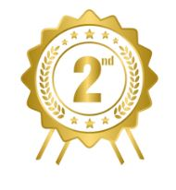
Arleigh Vayda
Jones Valley Elementary School
Middle Division
“Life”
Music sheet & pencil
Artist Statement
My work of art, Life, relates to the theme I’m hopeful because…..It relates by showing how some of the notes jump from high to low then the notes just kind of jump around. I have 2 younger siblings. It could either go high which means happy and nobody’s crying in the car. Or it could be low which is unhappy and everybody’s crying. But either way I’m hopeful for the highs and lows in my life.
