HCPTA Scholarship Application 2024
Deadline: March 1, 2024

The Huntsville Council of PTAs annually awards up to twelve (12) $500 scholarships – up to two
(2) scholarships per high school in the Huntsville City Schools system, provided such schools are in good standing with the Huntsville Council of PTAs and with Alabama PTA.

Scholarships are awarded to Huntsville City School seniors who plan to pursue higher education at any accredited institute of higher learning, including vocation and trade schools as well as two-year and four-
year colleges/universities. Note: Scholarship funds will be sent directly to the school of attendance, usually in June.

To apply you must complete both sections of this Google Form. All applications will be reviewed by a panel of judges and awarded points for each of the following components:

Essay/Video (up to 60 points);
Resume (up to 20 points - must include GPA); and
2 Letters of Recommendation (20 points, up to 10 points for each provided).

The essay/video and resume portions of the application will be scored using rubrics provided in Section 2 of this Google Form. We encourage you to review the rubrics (and résumé samples) as you prepare your application materials.
* Indicates required question

Email *

Click or tap here to enter text.

- Applicant’s Full Name *

Click or tap here to enter text.

- Applicant’s Mailing Address *

Click or tap here to enter text.

- Contact phone number for applicant

Click or tap here to enter text.

- Parent/Guardian Name(s) *

Click or tap here to enter text.

Click or tap here to enter text.

- High School Currently Attending *

Click or tap here to enter text.

- School you plan to attend after graduation? *
You may answer unsure.

Click or tap here to enter text.

- Have you been accepted to a school? *

Choose an item.

You will need to provide the following materials to complete your application: (a) an essay or two- minute video in response to the prompt below, (b) a résumé, and (c) two (2) letters of recommendation.

Essay/Video Prompt: How has parental involvement, the community, and/or PTA impacted your education and life in a positive way?

Please don't refrain from discussing any personal obstacles that may have been part of your educational journey such as financial struggles, different learning abilities, and/or family language barriers.

Written responses should be a two-page maximum essay. Essay should be typed using 12 point Times New Roman font and should be double-spaced with 1” margins. You may submit a video instead of a written essay on the same topic. Video to be no more than 2 minutes in length. The rubric shown below will be used to score your submission.

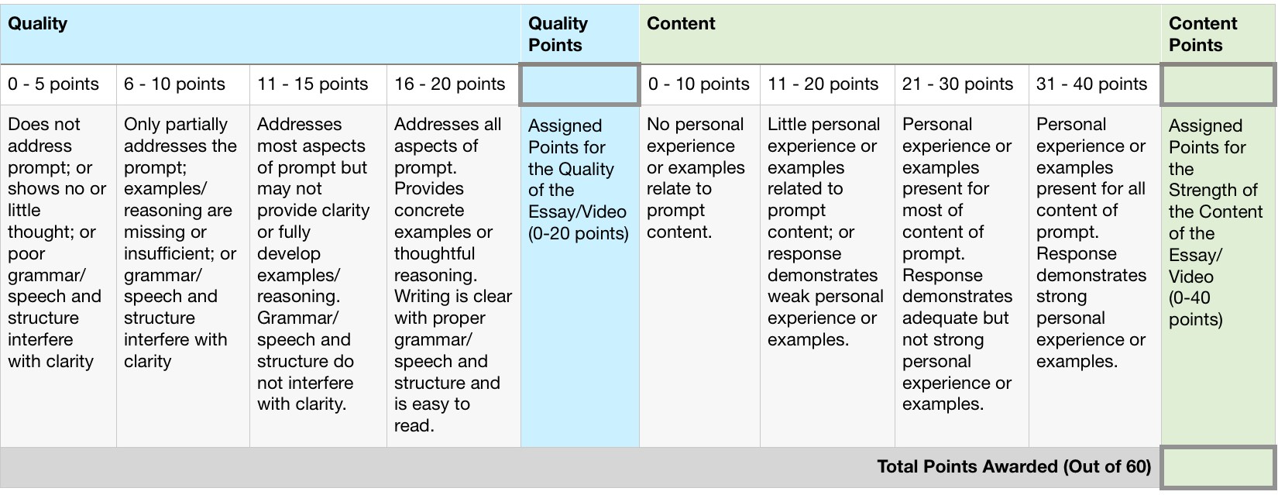

- Send Résumé as attachment. Before doing so, we welcome you to review the rubric and three (3) samples provided below. The samples are meant to serve as guides when creating your
own résumé if you do not already have one. Résumé is not judged on artistic effort. Focus on the content.
Files submitted:

Résumé Rubric

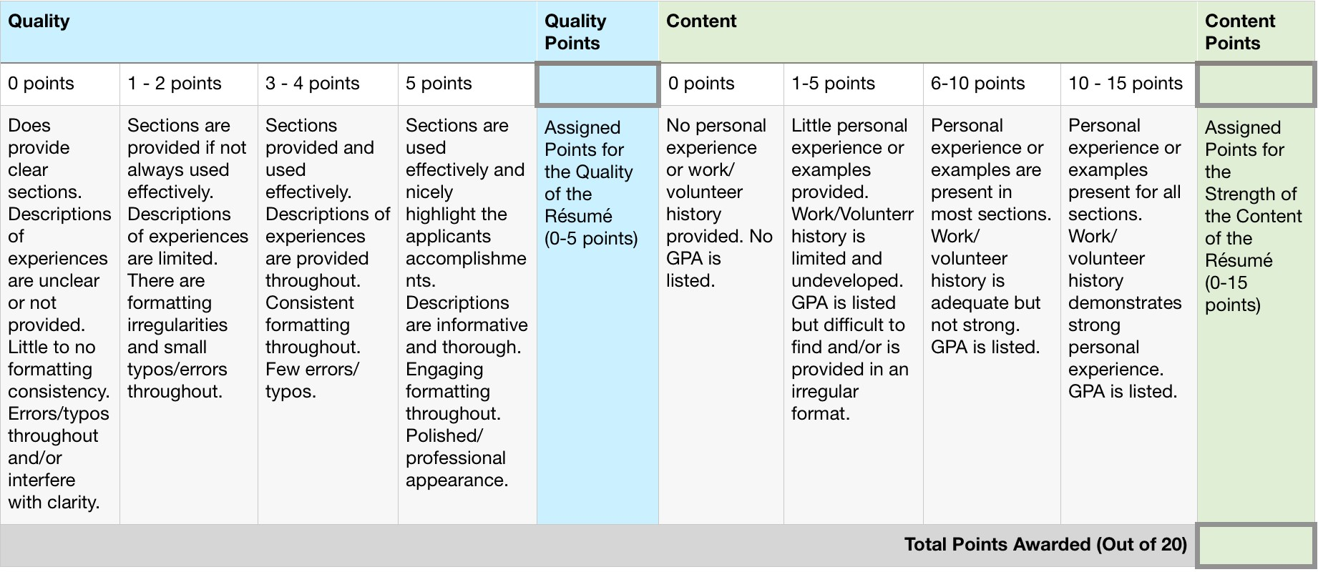

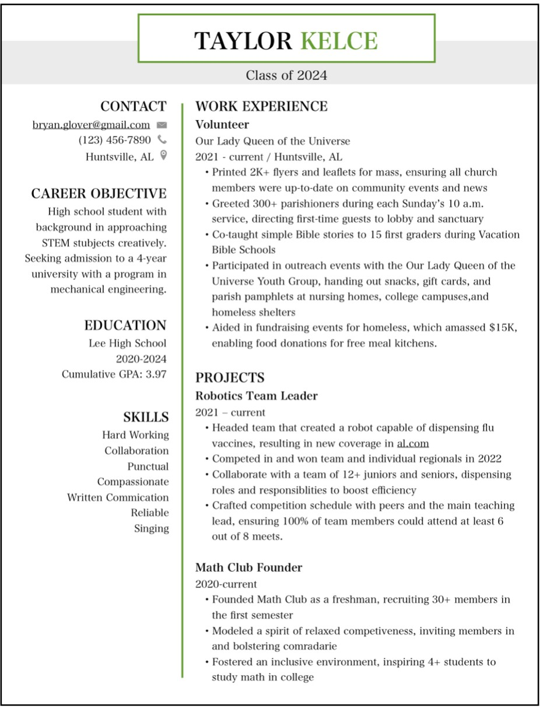

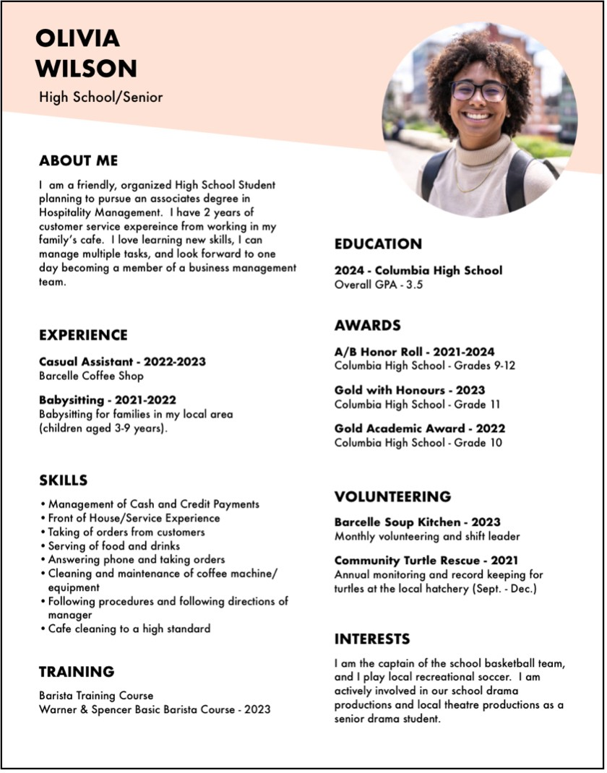

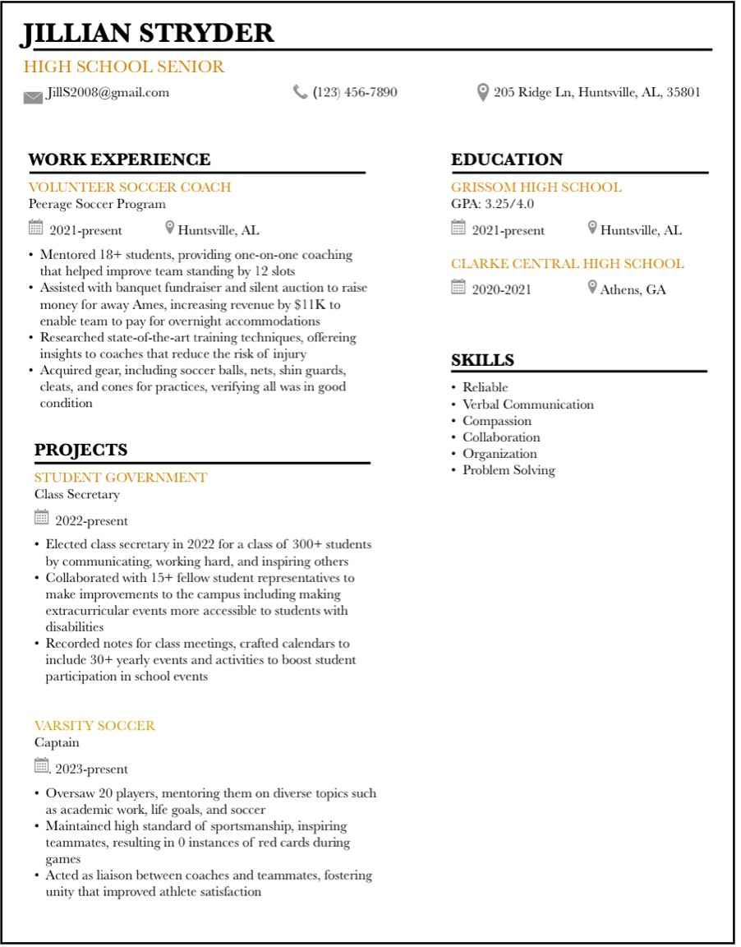

Don’t forget to include 2 letters of Recommendation, Résumé, essay or video with this completed form to programs@huntsvillepta.org

