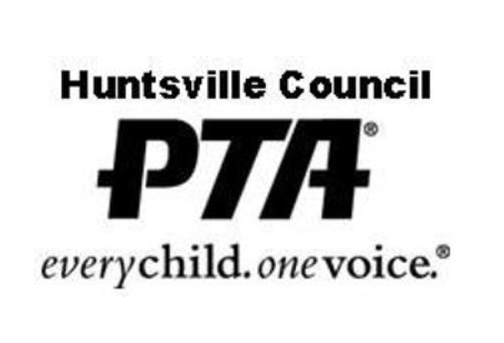
Huntsville Council of PTA’s
Board of Directors Meeting Minutes (Change title for Executive Board Meet)
Date | Location | Time | Called by |
In Attendance

Report of Officers
Board of Directors Meeting(Check title for Directors/Executive) of the 2021-2022 Huntsville Council of PTA’s.

I. Call to Order

II. Approval of Minutes of MM/DD/YYYY
EX.Motion was made to approve minutes, motion was moved and seconded. Minutes were approved as presented.

III. Officers Report-
-Treasurer |

-VP of Programs |

-Secretary |

-President |

-Additional Comments

The meeting was adjourned at 00:00a.m.
Next Meeting |
mm/dd/yyyy
Looking Ahead |
EX. Insert upcoming events and/or important dates
28 May End of Second Semester, Last Day for Students
27-28 May Graduation Days

