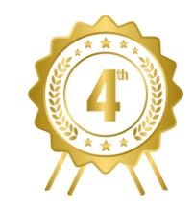
Anna Hummer
Challenger Elementary School
(Primary Division)
“When I Grow Up”
Poem

